Bridging and Transfers
Bridging is used in NG9-1-1 to transfer calls and conduct conferences. Bridges have a SIP signaling interface conformant to section 3.1 to create and maintain conferences and have media mixing capability. Bridges MUST be multimedia capable (voice, video, text). A bridge is necessary to transfer a call because IP-based devices normally cannot mix media and transferring always adds the new party (for example, a call taker at a transfer-to PSAP) to the call before the transferor (for example, the original call taker at the PSAP which initially answered the call) drops off the call.
Transferring calls that originate at an Agency
Calls may be originated by PSAPs and other Agencies in an ESInet, including calls that transit the OCIF (4.21) such as call backs. Such calls may need to be transferred. If the call is related to an open incident, an EIDO MAY be conveyed, otherwise an EIDO MUST NOT be conveyed. Transfers of calls that originate inside a PSAP SHALL use the Ad Hoc mechanisms described above, conforming to RFC4579 regardless of the bridge model used for emergency calls.
The flows described in section 4.8.1.1 are used, with the obvious substitution of “caller” with the entity inside the ESInet originating the call, and “transfer-from PSAP” and “transfer-to PSAP” being the entities originating and receiving the transfer. The OCIF (4.21) includes B2BUA capability to aid in transfers where one party in the transfer does not implement REFER. The procedures in Section 4.8.1.1.2 illustrate these flows with similar substitutions.
If a callback is transferred, the SIP Priority header field SHALL have the “sos.callback” value in the INVITE messages in the transfer sequence, where Follow Up and calls to other entities would not. Call Back calls and any other calls related to an open incident SHALL have the IncidentId of the incident in each INVITE.
This section is intended to cover calls that are received at a PSAP through mechanisms other than those described in this document, for example a call received via a PSTN connection in a PSAP. While such calls do not “originate” at a PSAP, if they are transferred the mechanisms described above SHALL be used.

Attended Transfers
This document describes two ways that bridging is employed. One way is termed “ad hoc” and is characterized by using a bridge only when it is needed during transferring or conferencing more than two parties. The text in the previous version of this document specified that, once a call with the ad hoc Bridge is established, the transfer-to “PSAP REFERs the caller to the bridge”. This is based on the premise the Bridge can reach the caller’s SIP User Agent (UA) handling the existing call (be it a 9-1-1 call from the caller or a Callback call) and tell the UA to release the existing call and instead use this newly received call (as specified by the Replaces header which specifies the existing call’s details), i.e. the Bridge will generate an INVITE with Replaces header generated from the details found in the REFER request and this INVITE will reach the caller.
Unfortunately, this is problematic for a number of reasons:
- If the caller’s identity is a TEL URI, it is impossible to craft a compliant REFER request which includes a Refer-To header with an embedded Replaces header
- If the caller is on the Public Switched Telephone Network (PSTN) and even if it used a SIP URI with parameter user=phone as its identity, there is no guarantee the INVITE will reach the same UA used by the existing call, if the call is sent to another PSTN gateway it will refuse the INVITE as it is not handling the existing call as specified in the Replaces header
- In order to increase the likelihood to reach the caller’s UA, the Transferring PSAP would need to include in the Refer-To header all Routes learned from Record-Route headers specified for the existing call. Due to the use of Session Border Controllers (SBC – which are security devices used to secure SIP sessions) and their propensity for Topology Hiding, the route used by the existing call is hidden to the Transferring PSAP thus impossible to provide to the Bridge so it can have the INVITE with Replaces follow it.

To address the above limitations, there are two alternative call flows which can be used to allow an Ad Hoc transfer to succeed:
- Instead of sending a REFER with a Refer-To header addressing the caller, the Transferring PSAP can send a REFER request via the existing call path addressing the Bridge’s Conference URI
- Instead of addressing the caller, the Transferring PSAP addresses the REFER sent to the bridge to the Contact URI it received for the existing call:
  - In the INVITE of the incoming 9-1-1 call or
  - In the 200 OK of the callback to the 9-1-1 caller.
This document will continue with option 2, as it is extremely similar to the existing Ad Hoc Conferencing call flow, the only difference is the URI specified in the Refer-To header.
The rough transfer sequence for ad hoc, based on the procedures defined in RFC 4579 [39], is:
- PSAP creates a conference on the bridge
- PSAP REFERs the existing call to the bridge by specifying its Contact URI
  - As found in the INVITE of the incoming 9-1-1 call or
  - As found in the 200 OK of the callback via OCIF to the 9-1-1 caller
- PSAP tears down the original PSAP-Caller leg
- PSAP REFERs transfer target (transfer-to PSAP for example) to the conference
- PSAP tears down its leg to the conference, the transfer-to PSAP and the caller remain
- Transfer-to PSAP REFERs the caller to it
- Transfer-to PSAP terminates the conference.
All Bridges SHOULD support ad hoc signaling as it is the only method which can be used to transfer PSAP outbound calls (such as Callback calls).
An NGCS implementation may wish to specify via SIP signaling which Conference Application (i.e. Conference Factory) a PSAP is to use instead of any provisioned or discovered Conference Application URI. For example, when the NGCS wants the PSAP to send the INVITE to the Conference Application associated to the SIP cluster handling the existing call. This is done by specifying a Call-Info header with parameter “purpose=emergency-ConferenceFactoryURI”, for example:
Call-Info: <sip:conference.ngcs.net>; purpose=emergency-ConferenceFactoryURI
Such a Call-Info header can be specified in an INVITE sent to a PSAP or in the 200 OK response to a PSAP’s outbound call (such as a Callback call). A PSAP receiving such a Call-Info header SHOULD use the specified Conference Application URI when accomplishing an ad hoc conference for the session in which the Call-Info header was received.
Note: When the caller drops voluntarily or involuntarily from the ad hoc Bridge, leaving only two participants, the ad hoc bridge must identify which participant will release the bridge resources. This can be achieved by moving the host in the <host-info> element on the conference subscription's NOTIFY. A future version of this document will normatively specify this behavior.
Some calling devices may not support the Replaces header field (which can be determined by examining the content of the Supported header field to see if a “replaces” option tag is present, or by completing an OPTIONS transaction and obtaining the Accept header field that way). If the calling device does not support the Replaces header field, then a B2BUA in the path MUST be present which does support the Replaces header field in an ESInet supporting ad hoc bridging. Often, this B2BUA will be part of the BCF. All calls are relayed through the B2BUA. The B2BUA is transparent to signaling with the following exceptions:
- The Contact URL is modified to be a URL of the B2BUA for both the caller (Contact in INVITE) and PSAP (Contact in 200 OK).
- The REFER method, when executed on the PSAP side to a conference bridge, causes the bridge to invite the B2BUA to the conference, and the B2BUA to respond as illustrated below. The leg between the caller and the B2BUA sees no transaction.
- An INVITE sent into an ESInet by a B2BUA in the call path MUST indicate support for REPLACES.
- If a B2BUA in the call path receives an INVITE from a caller that does not include a Supported header field containing the "replaces" option-tag, it MUST provide the functionality described in this section.
- Media endpoints towards both the caller and the PSAP MAY be rewritten to be contained within the B2BUA.
The other mechanism is “Route All Calls Via a Conference Aware UA”. In this mechanism, at least the signaling portion of a bridge is always in the call path, and transfer is accomplished by adding and deleting parties to the bridge. An element in the call path effectively operates as a B2BUA, modifying the call signaling towards the PSAP and the response to the caller so that it appears as a bridge in the path, and, when transfer is actually needed, what was a B2BUA operates as a true bridge, allowing the transfer-to PSAP to be added to the bridge and the transfer-from PSAP to drop from the bridge. Often, a media mixer is not in the path unless needed.
The high-level transfer sequence for this method is:
- The original call arrives at a conference-aware UA.
- The conference-aware UA acts as a B2BUA and modifies the signaling towards the PSAP by adding the conference marker (“isfocus”) and modifying the Contact to be itself rather than the caller.
- The PSAP gets the call and responds in the normal way. The response to the initial call will be sent to the conference-aware UA.
- The conference-aware UA modifies the response from the PSAP towards the caller by adding the conference indicator and modifies the Contact to identify itself. It MAY NOT modify the SDP, so the media is set up directly between the caller and the PSAP.
- At some point, the PSAP desires to transfer the call to a transfer-to PSAP. Since it has the ‘isfocus’ from the conference UA already, it sends the conference-aware UA a REFER to ask it to add the transfer-to PSAP to the conference.
- The conference-aware UA sends an INVITE to the transfer-to PSAP. It also MAY re-INVITE both the caller and the transfer-from PSAP, including SDP that moves the media to a media mixer if it was not already connected to one. The conference-aware UA is now acting as a normal bridge.
- All parties accept their INVITEs and a 3-way conference with media mixing ensues.
- The transfer-from PSAP then leaves the conference by sending a BYE.
- The conference-aware UA then MAY re-INVITE the caller and the transfer-to PSAP, including signaling that will move the media to be direct between the transfer-to PSAP and the caller.
When an NGCS implements Route All Calls Via a Conference Aware UA, calls placed by Agencies within the ESInet, and specifically calls placed via the OCIF, MUST NOT have the Bridge in the path of the call when it is placed. If transfers on such outbound calls are required, Ad Hoc signaling is used to engage a Bridge.
In an NGCS that implements the Route All Calls via a Conference-Aware UA, the Contact header SHOULD contain a media feature tag of “urn:emergency:conference-model:racvcau” immediately following the “isFocus” media feature tag, to alert recipients which model is used. An NGCS MAY include the media feature tag “urn:emergency:conference-model:adhoc” if it implements the Ad Hoc Bridge model.
Note: A future version of this document will require the urn:emergency:conference-model:racvcau media feature tag to be present when that model is used.
All Bridges in the ESInet/NGCS MUST implement the Session Recording Client interface defined by SIPREC (RFC 7866 [116] and RFC 9806 [244]). Provisioning MAY control whether the bridge does log media.
When the bridge is used to transfer a call, information including the location of the caller and any Additional Data received (or retrieved in conjunction) with the call MUST be conveyed to the transfer target. The emergency-Call Identifier and the emergency-Incident Tracking Identifier MUST be copied from the REFER to the outgoing INVITE. The REFER MUST contain a suitable URN, usually the URN used to query the ECRF to determine the correct responder, or an appropriate URN from the “urn:emergency:service:responder” tree if a specific responder was selected, a ‘serviceurn’ parameter of the Refer-To . An agency transferring a misrouted call to the proper PSAP typically uses “urn:service:sos”, but could use “urn:emergency:service:psap” if an ECRF was not used to reroute the call. The Refer-To header field contains the URI of the target (which may be returned from a LoST query) and MUST contain the Service URN (in the “urn:service:sos” or “urn:emergency:service” trees) as a quoted string in a ‘serviceurn’ header parameter. The REFER to the bridge has the bridge’s URI in the “To:” and in the Request-URI. It also contains a Referred-By header field (RFC 3892) [28] with the URI of the primary PSAP. When the INVITE is created by the bridge to the secondary PSAP is created by the bridge, the INVITE MUST contain the Service URN in the Request-URI, and a Route header field containing the URI found in the Refer-To header field. This URI MUST contain an “lr” parameter as per section 3.1. The INVITE MUST contain a Referred-By header field with the URI of the primary PSAP per RFC 3892. S/MIME protection of the referrer is OPTIONAL. If the REFER does not contain a ‘serviceurn’ parameter but does reference an EIDO, the bridge sets the Request-URI to “urn:emergency:service:sos”. Additionally, any information the PSAP has determined beyond what it was sent SHOULD be given to the transfer target. The mechanism for accomplishing this is to create an EIDO and include it by reference in the transfer operation. The transferor creates an EIDO and includes a reference to the EIDO in a Call-Info header field with a purpose parameter of “emergency-eido” as an escaped header field in the Refer-To header field. Note that the Refer-To header field MUST be a SIP URI. Tel URIs do not support purpose parameters. The bridge includes this header field in the INVITE it sends to the transfer target. The EIDO includes the location reported for the caller (as received, i.e., by-value or by-reference), the callback number, and any Additional Data included (or retrieved in conjunction with) the call. (See section 4.7.2 for further discussion.) An example of the associated header fields is shown below.
REFER sip:+12125551234@OSP-Provider.com SIP/2.0
…
Refer-To:<sip:Poison-Control@cnty.st.us?Call-Info=%3Chttps%3A%2F%2FNG911PSAP-A.911Authority-A.net%2Feido09245673%3E%3Bpurpose%3Demergency-eido>;serviceurn=”urn:service:sos”
…
A bridge is a Service: each element of a bridge MUST implement the notifier-side of ElementState, subject to certain conditions as described in section 2.4.1, and MAY implement the subscriber-side. As bridges are typically a local Service, it is RECOMMENDED that ServiceState for the bridge Service be implemented by each NGCS that provides a bridge Service. For the Ad Hoc case, the transfer-to PSAP MUST release the bridge when the transfer-from PSAP terminates its leg of the call in order to release bridge resources.
As discussed in section 5.7 of NENA 08-002 [70], there is a problem in that some devices which could originate 9-1-1 calls do not support the Replaces header field. If a PSAP needs to transfer a call originated by such a device, it cannot use the standardized SIP signaling to the caller as described above. With Route All Calls Via a Conference-Aware UA, the conference-aware UA never changes the leg towards the caller (unless it must re-INVITE to change SDP if the initial media was negotiated directly between the caller and the PSAP). Thus, the calling device need not support the Replaces header field. For the ad hoc method, to support devices that do not implement the Replaces header field, a Back-to-Back User Agent is needed between the caller and the bridge/PSAP. Often the B2BUA will be located in the BCF, because most commercial Session Border Controllers which are deployed within a BCF have that functionality built in. Some SBCs may “anchor” media, meaning that they terminate the caller’s media at the B2BUA and relay it towards the PSAP or bridge. Others may only affect the signaling. The B2BUA element will always be in the path for all callers if deployed, especially if it is part of the BCF but may not affect the signaling for callers that indicate support for Replaces.
Conferencing procedures are documented in RFC 4579 [39]. This document includes definition of an Event package that allows conference participants to manage the conference. In the message sequences below, all participants are conference-aware (that is, they implement the event package). A bridge SHOULD implement the notifier-side of the Conference-state event package. It is not necessary for the caller to be conference-aware. If the caller is not conference aware, the SUBSCRIBE to the conference package does not occur. The caller, or some element in the path, MUST implement the Replaces header field (see section 3.1.1.2). Three scenarios are illustrated below: Ad Hoc without B2BUA, Ad Hoc with B2BUA- and Route All Calls Via a Conference-Aware UA.
NOTE: Implementing the notifier-side of the Conference-state event package will be made mandatory in a future version of this document.

SIP Ad Hoc Flow with No B2BUA on Ingress Call Path

Creation of a Conference
This scenario described in the call flow depicted below follows section 5.4 of RFC 4579 [39].
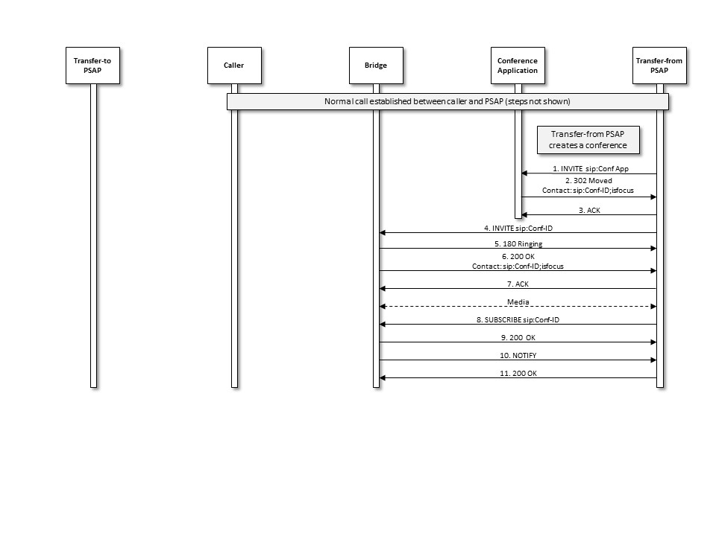
Figure 4-1. Ad Hoc Conference Call Flow Using SIP
- The transfer-from PSAP creates a conference by first sending an INVITE with specified Media in the SDP to a conference application, using a URI that is known by/provisioned at the transfer-from PSAP.
- The Conference Application responds by sending a 302 Moved message, which redirects the transfer-from PSAP to the conference bridge and provides the Conference URI that SHOULD be used for the conference.
- The transfer-from PSAP acknowledges the receipt of the 302 Moved message.
- The transfer-from PSAP generates an INVITE with specified Media in the SDP to establish a session with the conference bridge.
- The conference bridge responds to the INVITE by returning a 180 Ringing message.
- The conference bridge then returns a 200 OK message, and a media session is established between the transfer-from PSAP and the conference bridge.
- The transfer-from PSAP returns an ACK message in response to the 200 OK.
Media: If SDP includes media-type specification for audio and/or video and/or RTT, then RTP media is exchanged. If SDP includes media-type specification for MSRP, then MSRP messages are exchanged.
- through 11. Once the media session is established, the transfer-from PSAP subscribes to the conference associated with the URI obtained from the Contact header field provided in the 200 OK message from the conference bridge.

Transfer-from PSAP Asks Bridge to Invite the Caller to the Conference
This flow is based on section 5.10 of RFC 4579 [39].
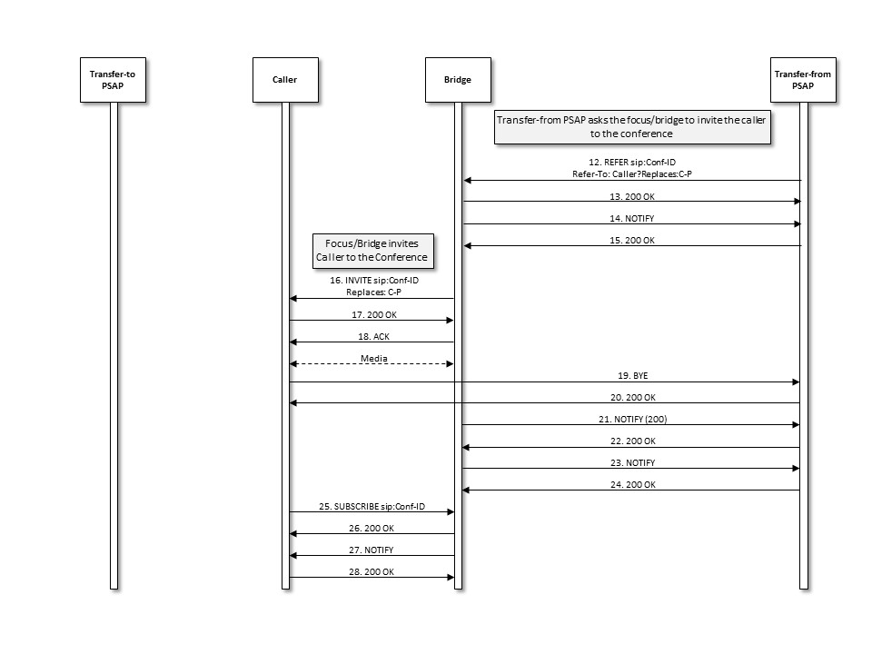
Figure 4-2 Transfer-from PSAP Asks Bridge to Invite the Caller to the Conference
- After the transfer-from PSAP establishes the conference, it sends a REFER method to the conference bridge asking it to invite the existing call’s Contact to the conference. The REFER method contains an escaped Replaces header field value in the URI included in the Refer-To header field, addressing the Contact URI learned from the either the received INVITE or the 200 OK of the outgoing call.
- The bridge returns a 200 OK message to the transfer-from PSAP.
- The bridge then returns a NOTIFY message, indicating the subscription state of the REFER request (i.e., active).
- The transfer-from PSAP returns a 200 OK in response to the NOTIFY message.
- The bridge invites the existing call’s Contact to the conference by sending an INVITE method containing the Conference URI and a Replaces header field that references the leg between the caller and the transfer-from PSAP and specified Media in the SDP.
- The existing call’s Contact accepts the invitation by returning a 200 OK message.
- The bridge acknowledges receipt of the 200 OK message by returning an ACK.
A media session is established between the caller and the bridge.
If SDP includes media-type specification for audio and/or video and/or RTT, then RTP media is exchanged. If SDP includes media-type specification for MSRP, then MSRP messages are exchanged.
- The existing call’s Contact releases the connection to the transfer-from PSAP by sending a BYE message.
- The transfer-from PSAP responds by returning a 200 OK message.
- The bridge sends a NOTIFY message to the transfer-from PSAP to provide REFER processing status.
- The transfer-from PSAP responds by returning a 200 OK message.
- The bridge sends a NOTIFY message to the transfer-from PSAP to provide updated status associated with the conference state.
- The transfer-from PSAP responds by returning a 200 OK message.
- The caller subscribes to the conference associated with the Conference URI provided in the INVITE message from the bridge by sending a SUBSCRIBE message to the bridge. (Optional)
- The bridge acknowledges the subscription request by sending a 200 OK message back to the caller. (Optional)
- The bridge then returns a NOTIFY message to the caller to provide subscription status information. (Optional)
- The caller responds by returning a 200 OK message. (Optional)

Transfer-to PSAP is Invited to the Conference
This flow is based on section 5.5 of RFC 4579 [39].
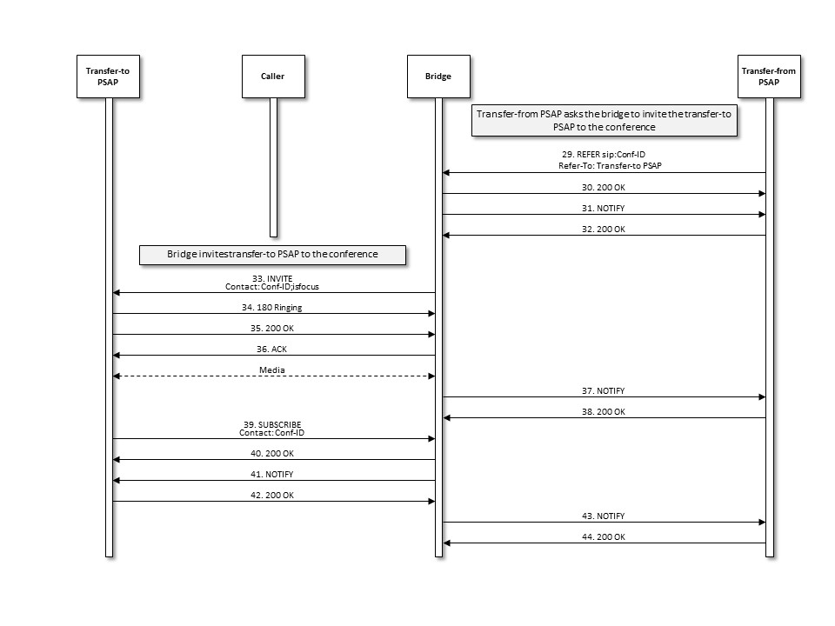
Figure 4-3 Secondary PSAP Invited to Conference
- The transfer-from PSAP sends a REFER method to the conference bridge asking it to invite the transfer-to PSAP to the conference. The REFER method contains the Conference URI and a Refer-To header field that contains the URI of the transfer-to PSAP. The REFER method also contains an escaped Call-Info header field value containing a reference URI that points to the EIDO data structure and a purpose parameter of ”emergency-eido”.
- The bridge returns a 200 OK message to the transfer-from PSAP.
- The bridge then returns a NOTIFY message, indicating that subscription state of the REFER request (i.e., active).
- The transfer-from PSAP returns a 200 OK in response to the NOTIFY message.
- The bridge invites the transfer-to PSAP to the conference by sending an INVITE method with SDP containing the Conference URI and Contact header field that contains the Conference URI and the ‘isfocus’ feature parameter. The INVITE contains the Call-Info header field containing a reference URI that points to the EIDO data structure and a purpose parameter of “emergency-eido”.
- The transfer-to PSAP UA responds by returning a 180 Ringing message to the bridge.
- The transfer-to PSAP accepts the invitation by returning a 200 OK message.
- The bridge acknowledges receipt of the 200 OK message by returning an ACK.
A media session is established between the transfer-to PSAP and the bridge.
If SDP includes media-type specification for audio and/or video and/or RTT, then RTP media is exchanged. If SDP includes media-type specification for MSRP, then MSRP messages are exchanged.
- The bridge returns a NOTIFY message to the transfer-from PSAP to provide updated status of the subscription associated with the REFER request.
- The transfer-from PSAP responds to the NOTIFY message by returning a 200 OK message.
- The transfer-to PSAP subscribes to the conference associated with the Conference URI provided in the INVITE message from the bridge by sending a SUBSCRIBE message to the bridge.
- The bridge acknowledges the subscription request by sending a 200 OK message back to the transfer-to PSAP.
- The bridge then returns a NOTIFY message to the transfer-to PSAP to provide subscription status information.
- The transfer-to PSAP responds by returning a 200 OK message.
- The bridge sends a NOTIFY message to the transfer-from PSAP providing updated status for the subscription associated with the REFER request.
- The transfer-from PSAP responds to the NOTIFY message by returning a 200 OK message.
At this point the caller, transfer-from PSAP, and transfer-to PSAP are all participants in the conference.

Transfer-from PSAP Drops Out of Conference; Transfer-to PSAP Completes Transfer
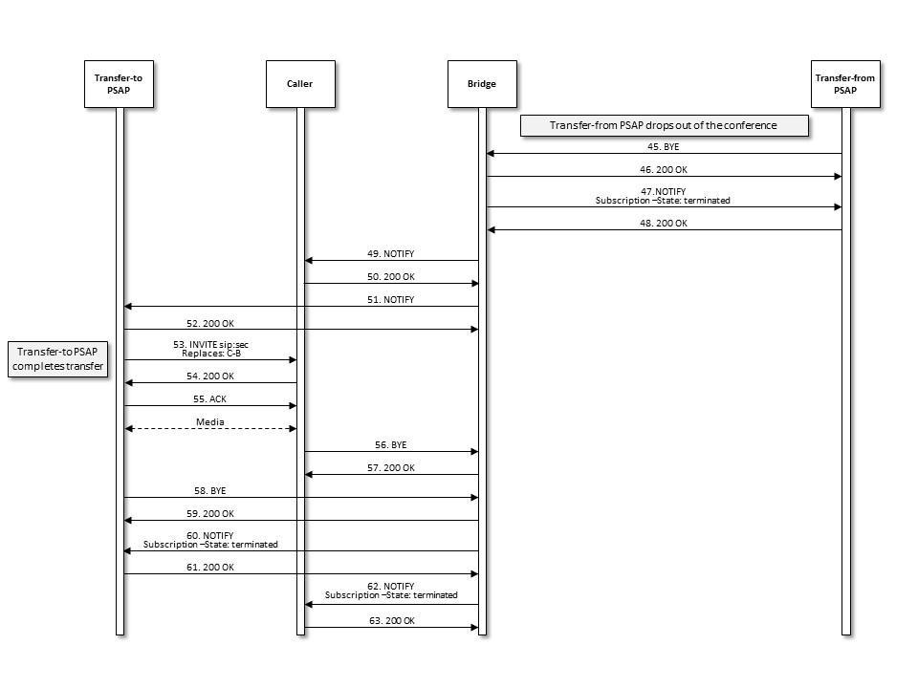
Figure 4-4 Transfer-from PSAP Drops, Transfer-to PSAP Completes Transfer
- Upon determining that the emergency call transfer should be completed, the transfer-from PSAP disconnects from the call by sending a BYE message to the bridge.
- The conference bridge responds by returning a 200 OK message.
- The bridge then returns a NOTIFY message indicating that the subscription to the conference has been terminated.
- The transfer-from PSAP returns a 200 OK in response to the NOTIFY.
- The bridge then returns a NOTIFY message to the caller indicating that there has been a change to the subscription state. (Optional)
- The caller returns a 200 OK in response to the NOTIFY. (Optional)
- The bridge returns a NOTIFY message to the transfer-to PSAP indicating that there has been a change to the subscription state.
- The transfer-to PSAP returns a 200 OK in response to the NOTIFY.
- Upon recognizing that the caller and the transfer-to PSAP are the only remaining participants in the conference, the transfer-to PSAP completes the transfer by sending an INVITE to the caller requesting that they replace their connection to the bridge with a direct connection to the transfer-to PSAP. The transfer-to PSAP learns the URI of the caller through the entity attribute in the endpoint section of the user’s container in the conference NOTIFY from the bridge.
- The caller responds by returning a 200 OK message to the transfer-to PSAP.
- The transfer-to PSAP returns an ACK in response to the 200 OK.
A media session is established between the transfer-to PSAP and the caller.
If SDP includes media-type specification for audio and/or video and/or RTT, then RTP media is exchanged. If SDP includes media-type specification for MSRP, then MSRP messages are exchanged.
- The caller then sends a BYE to the bridge to terminate the session.
- The bridge responds by sending the caller a 200 OK message.
- The transfer-to PSAP also terminates its session with the bridge by sending a BYE message to the bridge.
- The bridge responds by sending a 200 OK message to the transfer-to PSAP.
- The bridge then returns a NOTIFY message to the transfer-to PSAP indicating that the subscription to the conference has been terminated.
- The transfer-to PSAP returns a 200 OK in response to the NOTIFY message.
- The bridge sends a NOTIFY message to the caller indicating that the subscription to the conference has been terminated. (Optional)
- The caller responds with a 200 OK message. (Optional)
At this point, the transfer is complete, and the caller and the transfer-to PSAP are involved in a two-way call.

SIP Ad Hoc Method with B2BUA in the Ingress Call Path
This scenario is the same as above with the addition of the B2BUA for calling devices that do not support the Replaces header field. In this example, the B2BUA anchors media, although not all B2BUAs will do that.

Initial Call and Initial Conference Creation
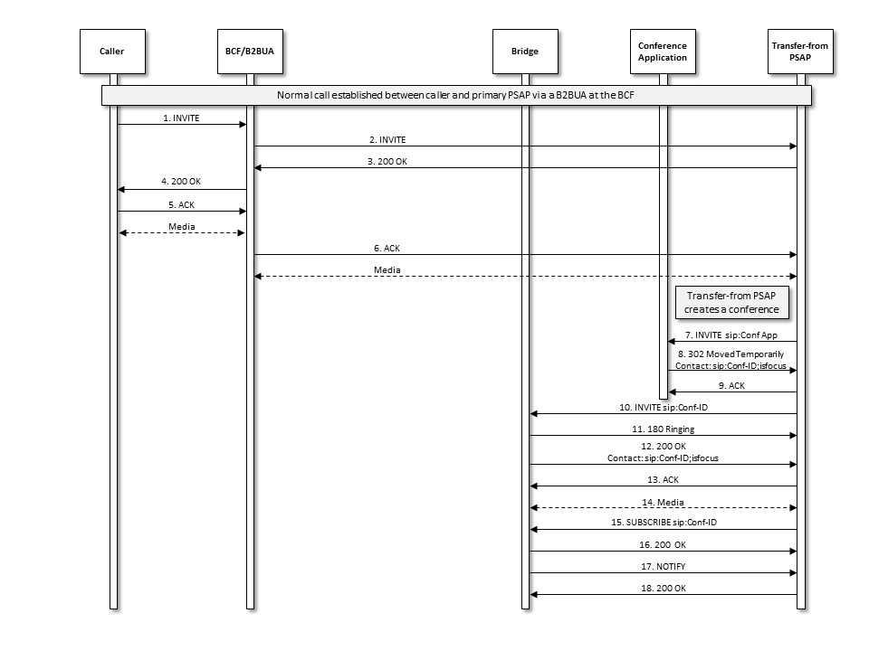
Figure 4-5 Ad Hoc Conference Call Flow Using SIP with B2BUA
- The caller initiates an emergency session request by sending an INVITE message to the B2BUA. The INVITE contains callback information and a Geolocation header with caller location information. The Supported header field does not indicate support for the Replaces header field.
- The B2BUA forwards the INVITE to the ESRP (the URI in the Route header field, which should contain the “lr” parameter to avoid Request-URI rewriting) after changing the Contact header field to point to itself and changing the offer SDP media endpoint address and port to be itself. The INVITE includes a Supported header field indicating support for Replaces. The call proceeds through the ESInet/NGCS normally, and arrives at a PSAP.
- The PSAP responds by returning a 200 OK message to the B2BUA, including its Contact URL and answer SDP in the response.
- The B2BUA responds to the receipt of the 200 OK from the PSAP by sending a 200 OK message to the caller’s device, changing the Contact to be itself and the answer SDP address and port to be itself.
- The caller’s device responds by sending an ACK to the B2BUA.
A media session is established between the caller and the B2BUA.
- The B2BUA sends an ACK to the PSAP in response to receiving an ACK from the caller’s device.
A media session is established between the B2BUA and the transfer-from PSAP.
- The transfer-from PSAP creates a conference by first sending an INVITE with specified Media in the SDP to a Conference Application, using a URI that is known by/provisioned at the transfer-from PSAP.
- The Conference Application responds by sending a 302 Moved message, which redirects the transfer-from PSAP to the conference bridge and provides the Conference URI that should be used for the conference.
- The transfer-from PSAP acknowledges the receipt of the 302 Moved message.
- The transfer-from PSAP generates an INVITE with specified Media in the SDP to establish a session with the conference bridge.
- The conference bridge responds to the INVITE by returning a 180 Ringing message.
- The conference bridge then returns a 200 OK message, and a media session is established between the transfer-from PSAP and the conference bridge.
- The transfer-from PSAP returns an ACK message in response to the 200 OK.
- Media. If SDP includes media-type specification for audio and/or video and/or RTT, then RTP media is exchanged. If SDP includes media-type specification for MSRP, then MSRP messages are exchanged.
- through 18. Once the media session is established, the transfer-from PSAP subscribes to the conference associated with the URI obtained from the Contact header field provided in the 200 OK message from the conference bridge.

Transfer-from PSAP Asks Bridge to Invite the B2BUA to the Conference
This flow is based on section 5.10 of RFC 4579 [39].
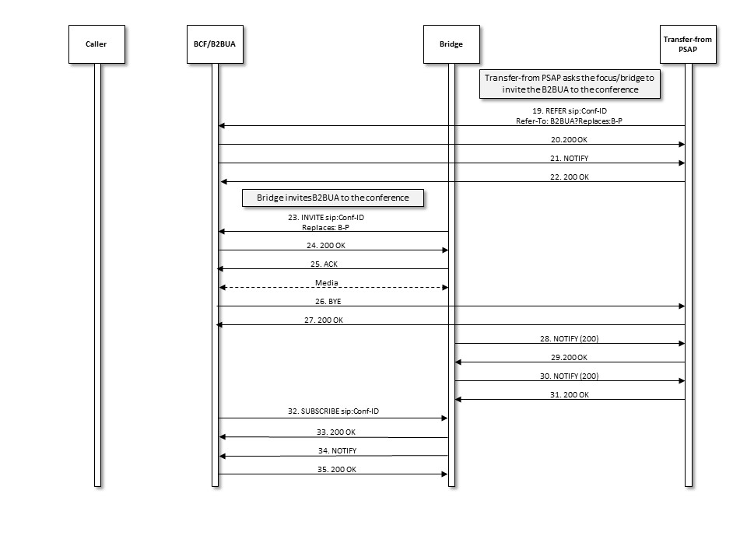
Figure 4-6 Transfer-from PSAP Asks Bridge to Invite the Caller/B2BUA to the Conference
- After the transfer-from PSAP establishes the conference, it sends a REFER method to the conference bridge asking it to invite the existing call’s Contact to the conference. The REFER method contains an escaped Replaces header field value in the URI included in the Refer-To header field, addressing the Contact URI learned from the either the received INVITE or the 200 OK of the outgoing call.
- The bridge returns a 200 OK message to the transfer-from PSAP.
- The bridge then returns a NOTIFY message, indicating the subscription state of the REFER request (i.e., active).
- The transfer-from PSAP returns a 200 OK in response to the NOTIFY message.
- The bridge invites the existing call’s Contact to the conference by sending an INVITE method containing the existing call’s Contact URI and a Replaces header field that references the leg between the B2BUA and the transfer-from PSAP and an SDP offer.
- The INVITE arrives at the B2BUA. It does not forward the INVITE. Instead, it accepts the invitation by returning a 200 OK message containing an answer SDP with the media address and port of itself.
- The bridge acknowledges receipt of the 200 OK message by returning an ACK.
A media session is established between the B2BUA and the bridge. The media session between the caller and the B2BUA is not affected. If SDP includes media-type specification for audio and/or video and/or RTT, then RTP media is exchanged. If SDP includes media-type specification for MSRP, then MSRP messages are exchanged.
- The B2BUA releases the connection to the transfer-from PSAP by sending a BYE message.
- The transfer-from PSAP responds by returning a 200 OK message.
- The bridge sends a NOTIFY message to the transfer-from PSAP to provide REFER processing status.
- The transfer-from PSAP responds by returning a 200 OK message.
- The bridge sends a NOTIFY message to the transfer-from PSAP to provide updated status associated with the conference state.
- The transfer-from PSAP responds by returning a 200 OK message.
- The B2BUA subscribes to the conference associated with the Conference URI provided in the INVITE message from the bridge by sending a SUBSCRIBE message to the bridge. (Optional)
- The bridge acknowledges the subscription request by sending a 200 OK message back to the B2BUA. (Optional)
- The bridge then returns a NOTIFY message to the B2BUA to provide subscription status information. (Optional)
- The B2BUA responds by returning a 200 OK message. (Optional)

Transfer-to PSAP is Invited to the Conference
This flow is based on section 5.5 of RFC 4579 [39]. There are no differences (other than step numbers) between this flow and the comparable flow in the no-B2BUA case.
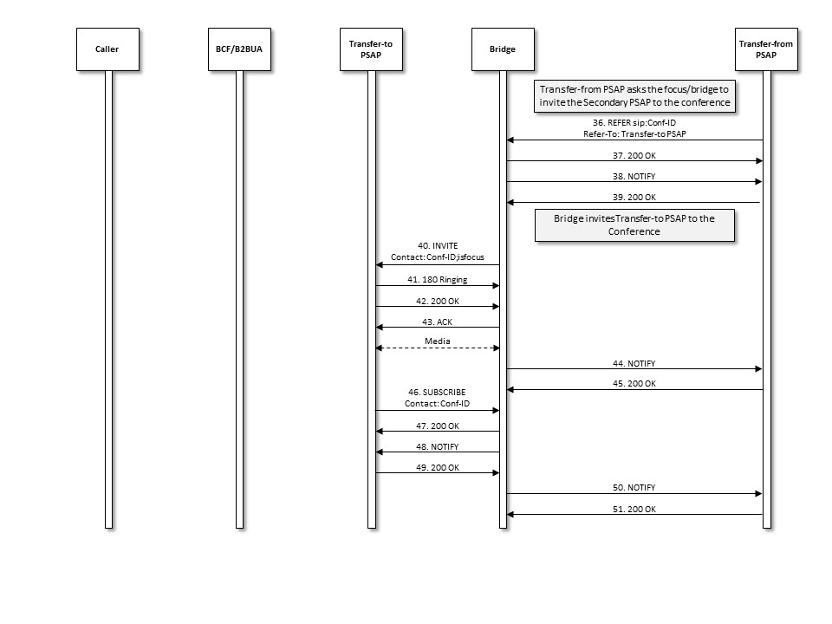
Figure 4-7 Transfer-to PSAP Invited to Conference
- The transfer-from PSAP sends a REFER method to the conference bridge asking it to invite the transfer-to PSAP to the conference. The REFER method contains the Conference URI and a Refer-To header field that contains the URI of the transfer-to PSAP. The REFER method also contains an escaped Call-Info header field value containing a reference URI that points to the EIDO data structure and a purpose parameter of “emergency-eido”.
- The bridge returns a 200 OK message to the transfer-from PSAP.
- The bridge then returns a NOTIFY message, indicating that subscription state of the REFER request (i.e., active).
- The transfer-from PSAP returns a 200 OK in response to the NOTIFY message.
- The bridge invites the transfer-to PSAP to the conference by sending an INVITE method containing the Conference URI and Contact header field that contains the conference URI, the ‘isfocus’ feature parameter, and an SDP offer. The INVITE contains the Call-Info header field containing a reference URI that points to the EIDO data structure and a purpose parameter of “emergency-eido”.
- The transfer-to PSAP UA responds by returning a 180 Ringing message to the bridge.
- The transfer-to PSAP accepts the invitation by returning a 200 OK message.
- The bridge acknowledges receipt of the 200 OK message by returning an ACK.
A media session is established between the transfer-to PSAP and the bridge. If SDP includes media-type specification for audio and/or video and/or RTT, then RTP media is exchanged. If SDP includes media-type specification for MSRP, then MSRP messages are exchanged.
- The bridge returns a NOTIFY message to the transfer-from PSAP to provide updated status of the subscription associated with the REFER request.
- The transfer-from PSAP responds to the NOTIFY message by returning a 200 OK message.
- The transfer-to PSAP subscribes to the conference associated with the Conference URI provided in the INVITE message from the bridge by sending a SUBSCRIBE message to the bridge.
- The bridge acknowledges the subscription request by sending a 200 OK message back to the transfer-to PSAP.
- The bridge then returns a NOTIFY message to the transfer-to PSAP to provide subscription status information.
- The transfer-to PSAP responds by returning a 200 OK message.
- The bridge sends a NOTIFY message to the transfer-from PSAP providing updated status for the subscription associated with the REFER request.
- The transfer-from PSAP responds to the NOTIFY message by returning a 200 OK message.
At this point the caller (via the B2BUA), transfer-from PSAP, and transfer-to PSAP are all participants in the conference.

Transfer-from PSAP Drops Out of Conference; Transfer-to PSAP Completes Transfer
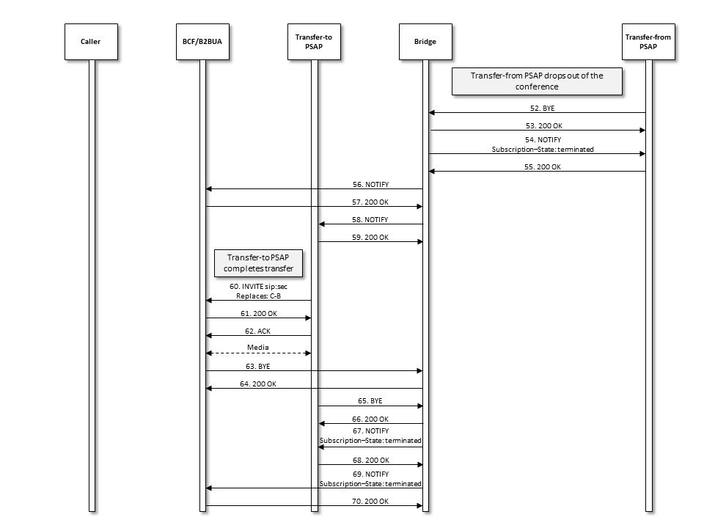
Figure 4-8 Transfer-from PSAP Drops, Transfer-to PSAP Completes Transfer
- Upon determining that the emergency call transfer should be completed, the transfer-from PSAP disconnects from the call by sending a BYE message to the bridge.
- The conference bridge responds by returning a 200 OK message.
- The bridge then returns a NOTIFY message indicating that the subscription to the conference has been terminated.
- The transfer-from PSAP returns a 200 OK in response to the NOTIFY.
- The bridge then returns a NOTIFY message to the B2BUA indicating that there has been a change to the subscription state. (Optional)
- The B2BUA returns a 200 OK in response to the NOTIFY. (Optional)
- The bridge returns a NOTIFY message to the transfer-to PSAP indicating that there has been a change to the subscription state.
- The transfer-to PSAP returns a 200 OK in response to the NOTIFY.
- Upon recognizing that the caller (via the B2BUA) and the transfer-to PSAP are the only remaining participants in the conference, the transfer-to PSAP completes the transfer by sending an INVITE with an SDP offer to the B2BUA requesting that they replace their connection to the bridge with a direct connection to the transfer-to PSAP. The transfer-to PSAP learns the URI of the B2BUA through the entity attribute in the endpoint section of the user’s container in the conference NOTIFY from the bridge.
- The B2BUA responds by returning a 200 OK message to the transfer-to PSAP.
- The transfer-to PSAP returns an ACK in response to the 200 OK.
A media session is established between the transfer-to PSAP, the B2BUA (acting as a media relay), and the caller. If SDP includes media-type specification for audio and/or video and/or RTT, then RTP media is exchanged. If SDP includes media-type specification for MSRP, then MSRP messages are exchanged.
- The B2BUA then sends a BYE to the bridge to terminate the session.
- The bridge responds by sending the B2BUA a 200 OK message.
- The transfer-to PSAP also terminates its session with the bridge by sending a BYE message to the bridge.
- The bridge responds by sending a 200 OK message to the transfer-to PSAP.
- The bridge then returns a NOTIFY message to the transfer-to PSAP indicating that the subscription to the conference has been terminated.
- The transfer-to PSAP returns a 200 OK in response to the NOTIFY message.
- The bridge sends a NOTIFY message to the B2BUA indicating that the subscription to the conference has been terminated. (Optional)
- The B2BUA responds with a 200 OK message. (Optional)
At this point, the transfer is complete, and the caller (via the B2BUA) and the transfer-to PSAP are involved in a two-way call via the B2BUA.

Call Termination
If the caller terminates the call, it sends a BYE to the B2BUA. The B2BUA forwards it to the transfer-to PSAP after modifying the Contact to itself. The transfer-to PSAP responds with a 200 OK which it sends to the B2BUA. The B2BUA then forwards the 200 OK to the caller. If the PSAP terminates the call, it sends a BYE to the B2BUA, which forwards it to the caller after modifying the Contact. The caller responds to the BYE with a 200 OK which it sends to the B2BUA. The B2BUA forwards that to the PSAP. (Steps not shown.)

As per RFC 3261, bridging and transfer flows described in this section support INVITEs with and without an SDP offer.
The ad hoc method described in this document functionally adheres to RFC 4579 however the terminology used herein may differ. For example, the “Bridge” relates to the “Focus” application in RFC 4579 and the “Conference Application” relates to the “Conference Factory” application in RFC 4579. The terms used herein should be interpreted broadly to support functionalities defined in RFC 4579.
Note that, based on RFC 4579, the messages sent in Steps 2, 3, and 4 are optional and may not be exchanged if the conference application and the media server are the same.
Note that, based on RFC 4579, the messages sent in Steps 2, 8, 9, and 10 are optional and may not be exchanged if the conference application and the media server are the same.

